1.
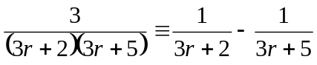 , 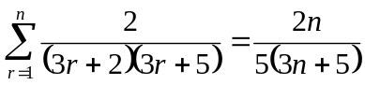

2.

3.
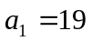 , 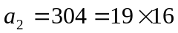 , 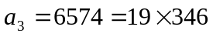 ,  is divisible by 19.

4.
When 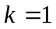, the solution set is 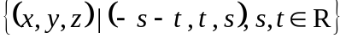
When 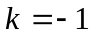, the solution set is 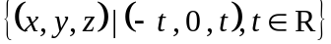
When 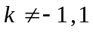, the solution set is 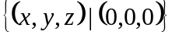

5.
(a) 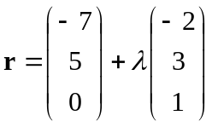
(b) 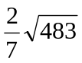

6.
(i) 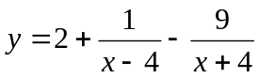
(ii) 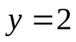 , 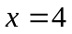 , 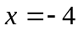
(iii) local maximum point : 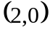 , local minimum point : 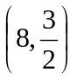
(iv) axial intercepts :  

